Functional annotation of proteins with comparative modelling of PNG1\png1p of Arabidopsis thaliana

Rambaldelli Guglielmo UniBo

ABSTRACT
We planned to model and annotate the product of PNG1 of Arabidopsis thaliana, we found out that the sequence was wrongly automatically annotated as the product of PNG1(PNGase) and instead it is the product of png1p(transglutaminase) as manually annotated in the literature[9].
We investigated the belonging of our target protein to the transglutaminase family but unfortunately we were not able to find crystallized vegetable transglutaminase, we managed to confirm the presence of the catalytic triad in the protein but the homology building process was not enough to reach a satisfying model given the low identity.
In the end we where able to confirm what exposed in the reference article but we can not transfer with certainty the GO terms from the template to the target.

1 - INTRODUCTION

The gene PNG1 is present in the UniProt[3] database as a PNGase but as soon as we search the database for homology we find out that there is png1p (Entry: A5PHD1) that has an identity and coverage of 100% but it is annotated as a Transglutaminase.

When BLASTED against the two family our sequence have a good identity with PNGase(~40%) and a really low identity with Transglutaminase.

This identity problem has already been reported [9] and in the study they found out that our target sequence is indeed a Transglutaminase because of his Ca induced activity and the lack of a Zn co-factor.

Unfortunately this implies that building by homology it is not possible give the really low identity and that a treading method should be more suited for it.

2 – METHOD

2.1 – DataBase
The known sequence has been aligned with UniProtKB[3] trought BLAST[1] (E 0.1) and we found out the presence of the same sequence with different annotation.
As a template as been used 1KV3 because was the one used in the prewious study[9].
The data regarding the template has been collected in PDB[2] and the annoation for it in UniProt[3] P21980.

2.2 – Computational Method
Our sequence has been aligned with 1KV3 with Lalign[4] using a global alignment BLOSOM 62 but unfortunatly the identity was to low (17.2%) to be plausible modelling it by homology so we decided to indagate the appartenence of our target to the transglutaminase family.

As described in the prewious study[9] the three main residues (CYS 251, HYS 278, ASP 295) are conserved in the sequence:
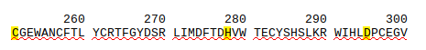

We tried to match our sequence to the core motif[10] of the transglutaminase family:

[GT]-Q-[CA]-W-V-x-[SA]-[GAS]-[IVT]-x(2)-T-x-[LMSC]-R-[CSAG]-[LV]-G

But it was not found in our sequence.

We alligned the target to a pool of transglutaminase sequence using ClustalOmega[11]:
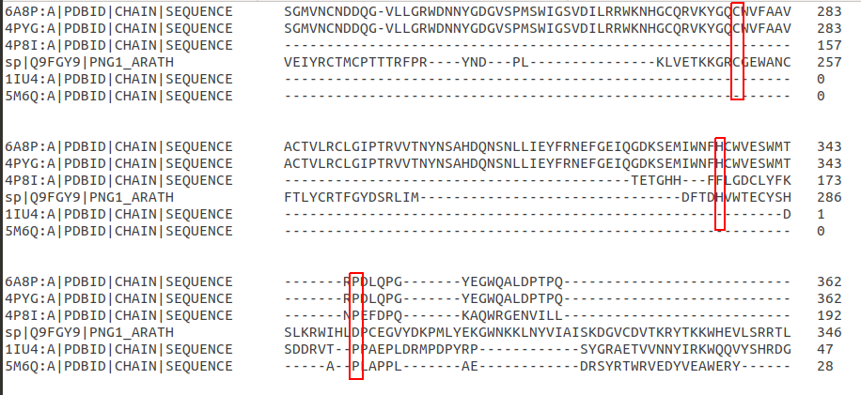
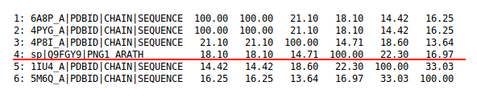
As we can see two of the three main residues are conserved in our sequence but the identity is really low:

Increasing the number of transglutaminase template we are able to see the conservatin of the residues but in doing that we have to sacrifice the integrity of the target sequence opening huge gaps in the structure:
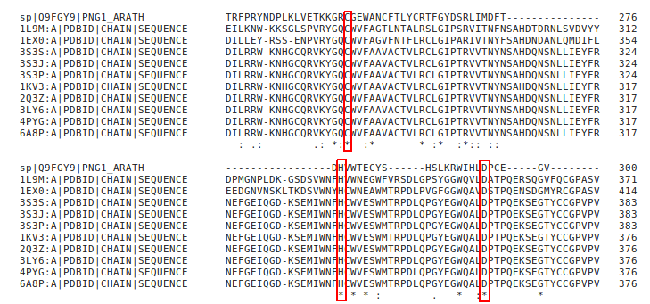

3 - TEMPLATE SELECTION

As a template has been chosen 1KV3 from the prewious study and we aligned the sequence with
clustal omega for the active site to indagate if conservation of the catalytic triad was possible:
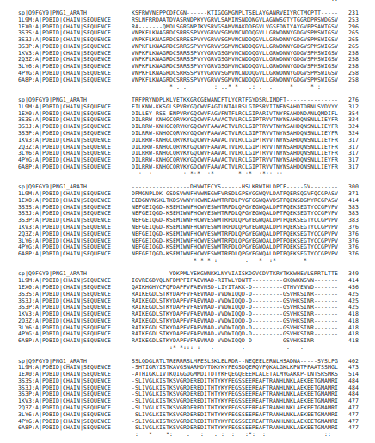

4 – MODELLER

Starting from the alignment we created a PIR file using only the site near the three main residues, unfortunatly the PDB file is incorrect and so we could only take the a few hundred residues.

Then we executed Modeller trought a Python script producing five different model(FIG. 4.1) and from the internal validation of modeller model 4 seems the best one.
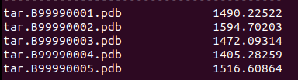

FIG. 4.1: Molpdf of the five model generated.

5 - PROCHECK
The created models has been check with procheck to analyze the dihedral angle and the resulting stability.

Ramachandran plot: 79.7% core 17.3% allow 1.0% gener 2.0% disall

As we expected given the low identity the model is not stable and has some residues in disallowed regions.
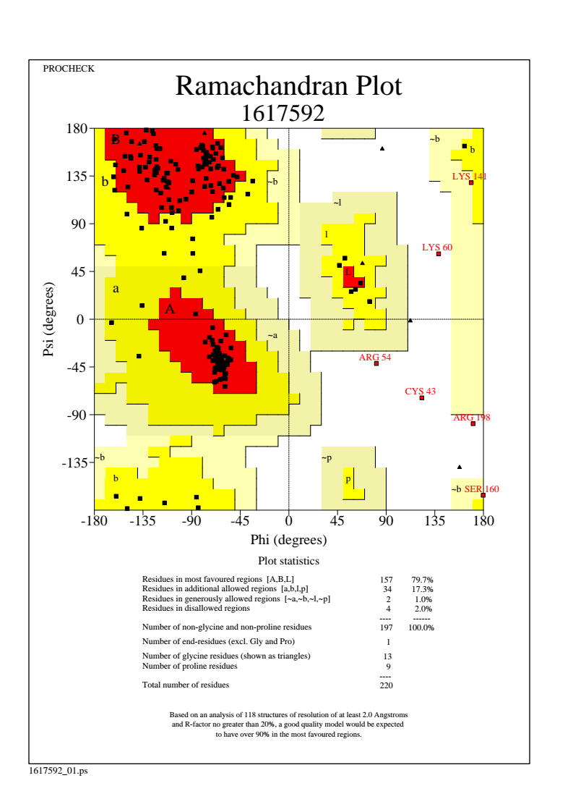

FIG. 5.1: Ramachandra plot of our model

6 - TARGET ANNOTATION

Chimera was used to superimpose the model to te template, we obteained a RSMD of 0.774 Armstrong with identity (20.24%).
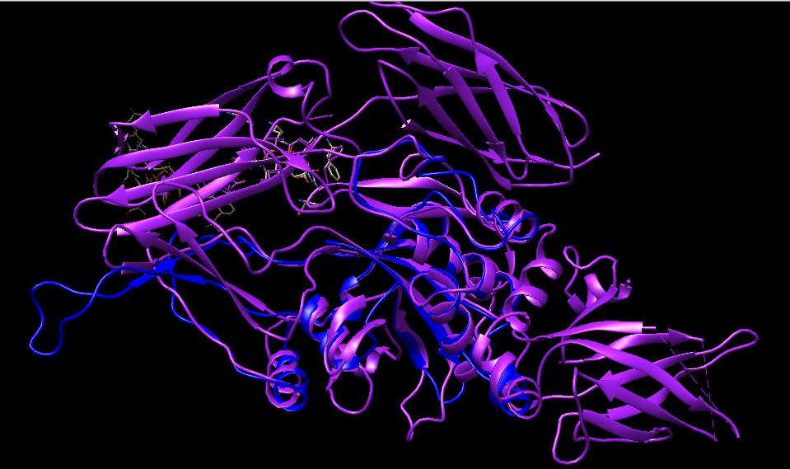
FIG. 6.1: Complete structure superimposition

6.1 – RESIDUE CONSERVATION

We check themain three residues needed for the catalytic activity:

CYS 251
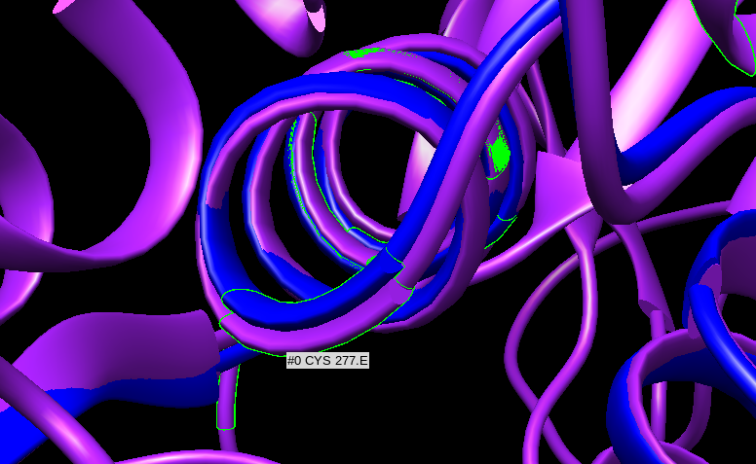

HIS 278
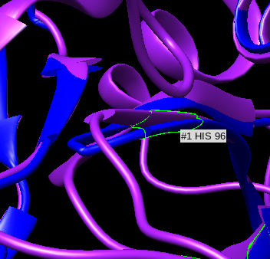
As we can see the residues are conserved
and so we can confirm what expound
in the source article[9].

ASP 295
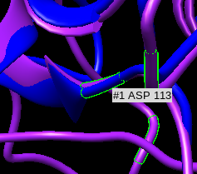

7 - FUNCTIONAL ANNOTATION

From the result of the omology modelling we can not be sure of the structure and function of our protein, we can however say that is has a the catalytic triad of a transglutaminase so we can transfer the GO term regarding it to the target.

8 – RESULTS AND DISCUSSION

In the end we can can confirm what shown in the article but other study based on other modelling method better suited for sequence with really low identity are reqired to correctly annotate the protein.

9 - REFERENCE

[1] BLAST at NCBI
Paper: PMID: 2231712
Release: 2.8.1: December 13, 2018
Link: https://blast.ncbi.nlm.nih.gov/Blast.cgi

[2] RCSB PDB
Authors: H.M. Berman, J. Westbrook, Z. Feng, G. Gilliland, T.N. Bhat, H. Weissig, I.N. Shindyalov, P.E. Bourne.
Paper: The Protein Data Bank Nucleic Acids Research, 28: 235-242.
Release: February 2016
Link: https://www.rcsb.org/

[3] UniProt
Paper: UniProt: the universal protein knowledgebase Nucleic Acids Res. 45: D158-D169 (2017)
Release: 2018_11 (05-Dec-2018)
Link: https://www.uniprot.org/

[4] Lalign
Author: William Pearson
The lalign program implements the algorithm of Huang and Miller, published in Adv. Appl. Math. (1991) 12:337-357.
Link: https://embnet.vital-it.ch/software/LALIGN_form.html

[5] Modeller
Author: Andrej Sali
Paper: A. Sali & T.L. Blundell. Comparative protein modelling by satisfaction of spatial restraints. J. Mol. Biol. 234, 779-815, 1993.
Release: 9.21, which was released on Dec 11th, 2018
Link: https://salilab.org/modeller/

[6] ProCheck at EMBL-EBI
Authors: Laskowski R A, MacArthur M W, Moss D S & Thornton J M (1993).
Paper: PROCHECK: a program to check the stereochemical quality of protein structures. J. Appl. Cryst., 26, 283-291.
Link: https://www.ebi.ac.uk/thornton-srv/software/PROCHECK/

[7] UCSF Chimera
Authors: Pettersen EF, Goddard TD, Huang CC, Couch GS, Greenblatt DM, Meng EC, Ferrin TE. J Comput Chem. 2004 Oct;25(13):1605-12.
Paper: UCSF Chimera--a visualization system for exploratory research and analysis.
Release: 1.13.1 17 november 2018
Link: https://www.cgl.ucsf.edu/chimera/

[8]Crystal Structure of a Laccase from the Fungus Trametes versicolor at 1.90-Å Resolution Containing a Full Complement of Coppers*
Author:Klaus Piontek‡, Matteo Antorini§, and Thomas Choinowski
Affiliation: From the Institute of Biochemistry, Swiss Federal Institute of Technology (ETH), ETH-Hönggerberg, Building HPM, Room D 8.1-2, CH-8093 Zürich, Switzerland

[9]Plant and animal transglutaminases: do similar functions imply similar structures?
Author: Serafini-Fracassini D1, Della Mea M, Tasco G, Casadio R, Del Duca S.
PMID: 18622667
DOI: 10.1007/s00726-008-0131-9

[10]InterProvScan
Authors: Philip Jones, David Binns, Hsin-Yu Chang, Matthew Fraser, Weizhong Li, Craig McAnulla, Hamish McWilliam, John Maslen, Alex Mitchell, Gift Nuka, Sebastien Pesseat, Antony F. Quinn, Amaia Sangrador-Vegas, Maxim Scheremetjew, Siew-Yit Yong, Rodrigo Lopez, and Sarah Hunter (2014).
Paper: InterProScan 5: genome-scale protein function classification. Bioinformatics, Jan 2014; doi:10.1093/bioinformatics/btu031
Link: https://www.ebi.ac.uk/interpro/

[11]Fast, scalable generation of high-quality protein multiple sequence alignments using Clustal Omega.
(2011 October 11) Molecular systems biology 7 :539
PMID: 21988835 The EMBL-EBI bioinformatics web and programmatic tools framework.
(2015 April 06) Nucleic acids research 43 (W1) :W580-4
PMID: 25845596 Analysis Tool Web Services from the EMBL-EBI.
(2013 May 13) Nucleic acids research 41 (Web Server issue) :W597-600
PMID: 23671338
Link: https://www.ebi.ac.uk/Tools/msa/clustalo/

